Lionsgate to Acquire Starz in $4.4B Deal
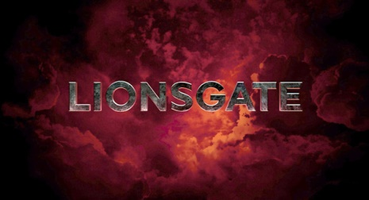
Lionsgate ended speculation Thursday when it confirmed that it will be purchasing Starz in a $4.4 billion cash-and-stock deal. The new deal will give Lionsgate distribution rights for Starz and Encore programming, and the merged companies will have a library of 16,000 movies and TV shows.
Multichannel News 6/30/16
http://www.multichannel.com/news/content/lionsgate-buy-starz-44b/406065

