Little Progress for Women on Broadcast TV
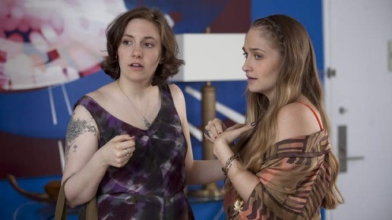
There have been a few increases in the depiction of women of color on TV, the study found. But as a whole, the industry continues to lag when it comes to the hiring of women, and it continues to engage in stereotyped depictions when women are on screen.
Variety 9.13.17
http://www.tvnewscheck.com/article/107213/hurricane-telethon-raises-over-14-million?utm_source=Listrak&utm_medium=Email&utm_term=Hurricane+Telethon+Raises+Over+%2414+Million&utm_campaign=WDAF+Ahead+In+Kansas+City%e2%80%99s+Social+Actions

