Live Commercials to Air During NBC's "Hairspray Live!"
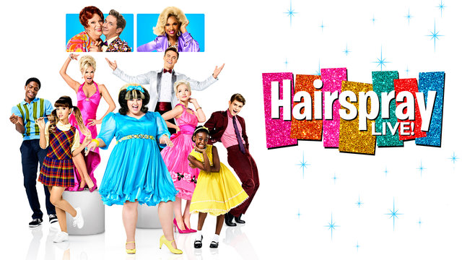
NBC plans to air live commercials during the "Hairspray Live!" performance set to air tonight. Commercials for Toyota, Reddi Wip and Oreo will feature 1960s backdrops and musical numbers.
The Associated Press 12/6/16
http://bigstory.ap.org/article/9c133628a12648d793ca1a085045b321/nbc-air-some-live-commercials-during-its-live-musical

