Local Stations Respond To Buffalo, N.Y., Mass Shooting
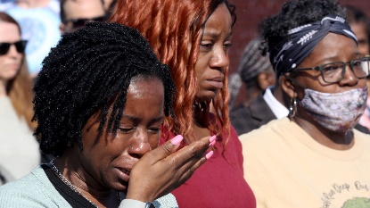
News teams at radio stations in Buffalo, N.Y., jumped into action as news of an active shooter in a local grocery store spread on May 14. Tim Wenger of WBEN, which suspended commercials on Saturday and for Sunday's press conferences, said that the station is "in the triage mode of what the community needs."
Inside Radio (free content) 5/17/22
https://www.insideradio.com/free/covering-the-buffalo-shooting-get-ready-this-is-going-to-be-chaotic/article_da2f20f2-d5ab-11ec-851c-63fd843f32ce.html
Image credit:
https://www.gannett-cdn.com/presto/2022/05/15/PWES/87c18a77-44fa-48d3-b1fd-2c12acf4f890-sh051522buffaloshooting016.JPG?crop=5471,3078,x0,y0&width=3200&height=1801&format=pjpg&auto=webp

