Location-Based Marketing Gains Traction
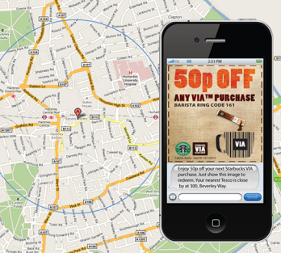
The majority of marketers and agencies (52%) surveyed by Reveal Mobile used location-based promotions prior to the coronavirus pandemic and as of July, have increased their frequency or spending allocation, with an additional 16% beginning to using the tactic due to the pandemic. Marketers surveyed also said the greatest opportunities in location-based targeting are for food and beverage, followed by health and beauty, entertainment, grocery, pets and animals, household goods and auto and service.
MediaPost Communications 8.24.20
https://www.mediapost.com/publications/article/355038/average-cpm-for-location-based-audiences-might-sur.html
Image credit:
http://www.hottelecom.com/images/reports/location-based-large.png

