Ohio LPFM Faces Displacement If FCC OKs Full-Power FM
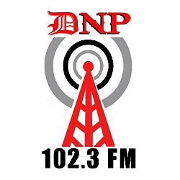
The FCC has indicated it could add a new full-service FM in northeastern Ohio in response to a request from Western Radio Group, which says it will apply for the frequency if approved. The move could displace Dover, Ohio, LPFM WDNP, which is currently operating on the 102.3 MHz frequency where the new station would be located.
Radio World 4/13/23
https://www.radioworld.com/news-and-business/business-and-law/fcc-looks-to-grant-new-full-service-fm-in-ohio?utm_term=A25693A1-51B6-4112-BDE4-56BD420E983F&utm_campaign=45863C53-9E40-4489-97A3-CC1A29EF491D&utm_medium=email&utm_content=C0E9B16B-0320-436F-B1E9-0D300796EA9F&utm_source=SmartBrief

