Many Americans Say Made-Up News Is a Critical Problem
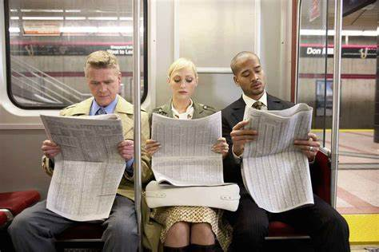
Indeed, more Americans view made-up news as a very big problem for the country than identify terrorism, illegal immigration, racism and sexism that way. Additionally, nearly seven-in-ten U.S. adults (68%) say made-up news and information greatly impacts Americans’ confidence in government institutions, and roughly half (54%) say it is having a major impact on our confidence in each other.
Pew Research Center 6.5.19
https://www.journalism.org/2019/06/05/many-americans-say-made-up-news-is-a-critical-problem-that-needs-to-be-fixed/?utm_source=Listrak&utm_medium=Email&utm_term=Pew%3a+Americans+Say+Made-Up+News+Damaging&utm_campaign=Cameras%2c+Monitors+Change+Triple+Crown+Viewing
Image credit:
https://www.bing.com/images/search?view=detailV2&ccid=gyQlBiua&id=6B6B8E989F318BE79E184F9AF056C20AF667A860&thid=OIP.gyQlBiua1YAf9I7kbzFJ0wHaE8&mediaurl=http%3a%2f%2fcdn.publishyourarticles.net%2fwp-content%2fuploads%2f2015%2f07%2freading-newspaper.jpg&exph=1000&expw=1500&q=people+with+news&simid=608053869136186401&selectedIndex=0&ajaxhist=0

