Magazine Circulation Takes a New Hit
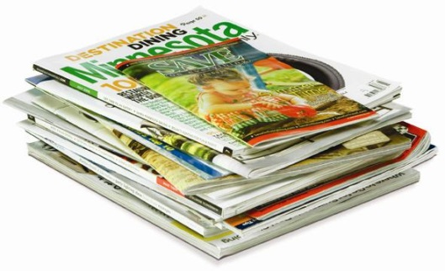
Time was one of many suffering magazine circulation declines on the newsstand, off 8.7 percent. The long-term trend for the magazine industry has become quite clear: Circulation declines, including steep ones at the newsstand, with occasional peaks and valleys. As for subscriptions, they remain on a slow decline, down 1.5 percent.
MediaLife 8.10.15
http://www.medialifemagazine.com/magazine-circulation-takes-a-new-hit/

