Maine Appeals Ruling Striking Down A La Carte Cable Law
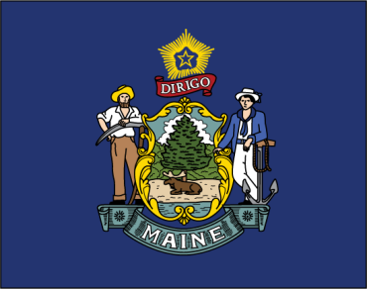
Aaron Frey, Maine's attorney general has moved to appeal a federal court decision that struck down a pioneering law requiring cable companies to offer channels on an a la carte basis. The lower court ruled the law violated Comcast's First Amendment rights, but Frey argued that the Constitution does not protect cable's business strategies.
Multichannel News 1.23.20
https://www.multichannel.com/news/maine-challenges-courts-blocking-of-a-la-carte-law

