Majority Of Consumers See Broadband As Essential
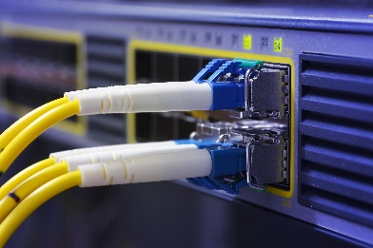
Consumers see broadband as essential, with Recon Analytics reporting that less than 10% of respondents in a new study saying they plan to reduce broadband or mobile spending. Respondents would prefer to reduce their spending on car payments, electricity and heating.
Telecompetitor 5.1.23
https://www.telecompetitor.com/report-telecom-spending-has-become-recession-proof/
Image credit:
http://s3.amazonaws.com/digitaltrends-uploads-prod/2014/10/Broadband-Internet.jpg

