Marketers Favor Mobile Push Notifications
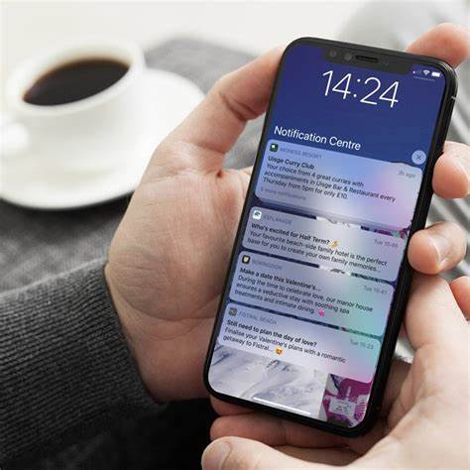
A OneSignal survey of 500 marketing customers found that 61% say push notifications via mobile is the top channel and the most effective means of re-engagement, followed by email and web channels. OneSignal analysis of 100 billion messages found in-app messages can deliver up to 30 times higher click-thru rates than push notifications and personalized messages yield 259% higher engagement rates than those with standard content.
MediaPost Communications (free registration) 4.26.22
http://r.smartbrief.com/resp/oXjMDwljflhaotkIazbVfgalbvKE?format=multipart
Image credit:
https://www.criton.com/media/3862/push-notifications-02.jpeg?anchor=center&mode=crop&quality=85&width=1200&height=1200&rnd=132447333760000000

