Maynard Launches New Diversity Initiatives
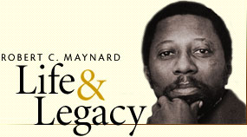
It’s developing a new training to teach students how to report more thoughtfully on stories that involve issues such as race or class, so that colleges and universities can be better prepared to “navigate the nuances of a more diverse society,” according to Maynard co-executive director Martin G. Reynolds.
Niemanlab.org 8.9.17
http://www.niemanlab.org/2017/08/after-a-strenuous-year-of-rethinking-its-mission-the-maynard-institute-launches-new-diversity-initiatives/

