Media Firms Make a Big Push into Video Streaming
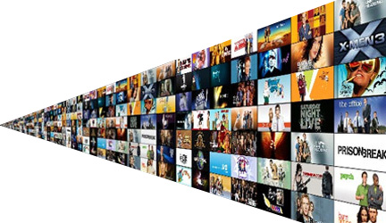
Entertainment companies are eager to hold on to consumers considering cutting the cable cord. They also hope to appeal to consumers who live in an estimated 10 million to 15 million homes in the U.S. that have high-speed Internet access but do not subscribe to a pay-TV subscription. And they also would like to beat Internet streaming pioneers Netflix and Hulu at their own game by fashioning more robust services.
Los Angeles Times 3.3.16
http://www.latimes.com/entertainment/envelope/cotown/la-et-ct-espn-hbo-direct-20160303-story.html

