5 Media Kits Worth Studying
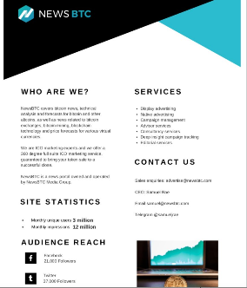
Vikas Agrawal, Infobrandz.com co-founder, details requisite media kit elements and highlights five corporate productions that offer valuable lessons in branding and credibility building. Among the five examples is Airbnb's easy-to-navigate online hub that offers for timely information.
Entrepreneur 3.16.23
https://www.entrepreneur.com/growing-a-business/5-beautiful-examples-of-a-strong-media-kit/446906
Image credit:
https://www.shoutmeloud.com/wp-content/uploads/2014/03/Bitcoin-site-media-kit-874x1024.jpg

