Mexican Newspaper Closes Citing Insecurity for Journalists
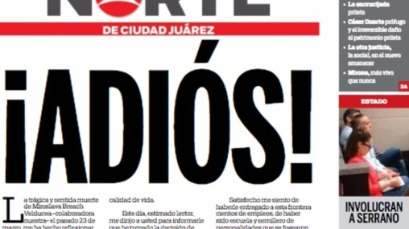
Norte executive Oscar Cantu Murguia informed readers of his decision in a farewell letter titled "Adios!". He cited the recent murder of journalist Miroslava Breach in the city of Chihuahua, which like Juarez is in Chihuahua state. Breach was a reporter for the national newspaper La Jornada and had also collaborated with Norte.
Associated Press 4.3.17
https://apnews.com/69656e989d6e4599a50a3fb82a2c7beb/Mexican-newspaper-closes-citing-insecurity-for-journalists?utm_source=API+Need+to+Know+newsletter&utm_campaign=ddd0a683a8-EMAIL_CAMPAIGN_2017_04_03&utm_medium=email&utm_term=0_e3bf78af04-ddd0a683a8-31697553
Image source:
http://progresohispanonews.com/wp-content/uploads/2017/04/b335da553a4ae0d8af95e4ff0bdf4289-1140x641.jpg

