MGM to Take Full Control of Epix in $1B Deal
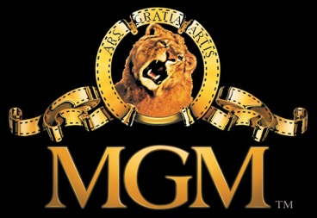
MGM is to take full control of Epix after buying out Paramount Pictures and Lionsgate in a $1 billion deal. The deal, which still has to be approved by regulators, is expected to close this month, and it includes theatrical releases from Paramount and Lionsgate under multiyear agreements.
Los Angeles Times 4.5.17
http://www.latimes.com/business/hollywood/la-fi-ct-mgm-epix-viacom-lionsgate-20170405-story.html

