Microsoft Plans To Enter Mobile Gaming Arena In 2024
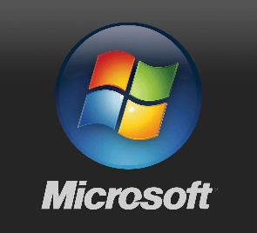
Apple and Google dominate the distribution of mobile apps, but Microsoft plans to take advantage of a change in Europe's laws next year to carve out a niche with its own store featuring Xbox-related products. Microsoft has acquired several game developers in recent years and is in regulatory talks to add Activision Blizzard to its stable.
The Verge 3/20/22
https://www.theverge.com/2023/3/20/23648112/microsoft-xbox-mobile-store-2024-launch

