Microsoft Prepares To Launch Xbox Game Ads
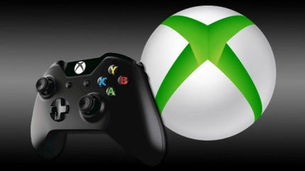
Microsoft is planning a selective marketplace that enables specific brands to run non-intrusive ads within the Xbox games that players don't have to pay for, a Business Insider report states. The company, which declined to comment, reportedly won't use proprietary data for ad targeting and will let ad firms and game developers share revenues.
The Verge 4/16/22
https://www.theverge.com/2022/4/16/23027934/microsoft-report-ads-free-to-play-xbox-games
Image credit:
https://cdn.gamesnort.com/mass_content/articles/ps5-vs-xbox-scarlett/xboxscarlett-1280x720.jpg

