Microsoft's LinkedIn Purchase Looks Good for Advertisers
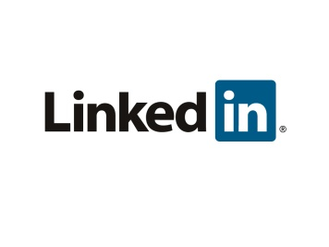
Microsoft has acquired LinkedIn for $26.2 billion, and the deal could give advertisers, especially business-to-business brands, better targeting and extended reach to LinkedIn's 433 million-strong audience. Microsoft has also indicated that it might introduce a newsfeed on the platform that will curate content "for every professional to stay connected with the happenings in their network, industry and profession" as one potential advertising option.
Marketing Land 6/13/16
http://marketingland.com/microsoft-linkedin-advertisers-180575

