Microsoft Rural 'Net Plan Uses White Spaces
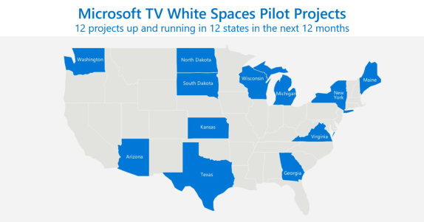
Microsoft is partnering with organizations across the country to form Connect Americans Now (CAN), a coalition that will pressure policymaker to help bring broadband internet access to rural America using unoccupied TV channels, or white spaces.
GeekWire 1.3.18
https://www.geekwire.com/2018/microsoft-forms-coalition-bring-high-speed-internet-rural-communities/
Image source:
https://www.windowscentral.com/sites/wpcentral.com/files/styles/larger/public/field/image/2017/07/ms-rural-broadband.png?itok=cT6IeOE7

