Young Consumers Say They'd Be Better Off Without Social
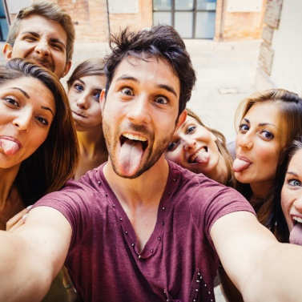
Just 26% of millennials and Generation Z across the world believe the economic prospects in their home countries will improve in the next year, a figure that has never before dropped below 40%, Deloitte reports. Additionally, 42% of millennials have deepened or started a relationship with a brand due to its positive social impact and 60% of them, along with 59% of Gen Z, say spending less time on social would make them happier.
Media Post Communications 5.28.19
https://www.mediapost.com/publications/article/336319/kind-of-a-sad-story-pessimism-increases-among-mil.html
Image credit:
http://livehapi.com/wp-content/uploads/2015/04/iStock_000043167130Large-1024x1024.jpg

