Millennials Favor Smartphones for Second-Screening
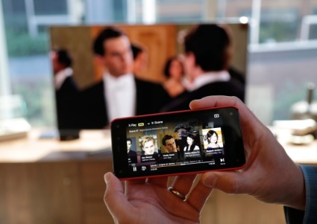
Despite TV's widespread reach, the attention of its US audience is something that's increasingly fractured across several devices. eMarketer estimates that 185.8 million adults in the US will regularly use the internet on a second-screen device while watching TV this year, an increase of 4.5% from last year's figure.
eMarketer 1.12.18
https://www.emarketer.com/content/millennials-favor-smartphones-for-second-screening?ecid=NL1001
Image credit:
https://i.cbc.ca/1.3350469.1449237132!/cpImage/httpImage/image.jpg_gen/derivatives/original_620/amazon-smartphone.jpg

