MLB May Soon Play Ball in a New Place: Facebook
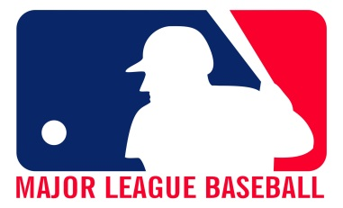
The league is in talks with the social network to stream a weekly game. Facebook believes video content, and not updates about your second cousin’s views on Donald Trump, will be the future of the social network, and it’s investing heavily in that future. MLB will get a way to connect with young people.
MediaLife 2.22.17
http://www.medialifemagazine.com/mlb-may-soon-play-ball-new-place-facebook/

