Report: Mobile Ad Engagement Up During Pandemic
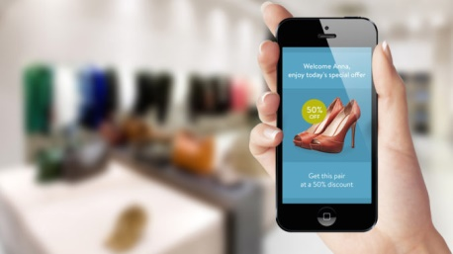
Mobile ad engagement has increased 15% during the past few months, coinciding with the coronavirus pandemic, with lower- and higher-income level households reaching record levels, according to a MobileFuse report. Women have demonstrated the highest engagement levels, and individuals in rural and suburban areas have been more responsive to mobile ads than individuals in urban areas.
Mobile Marketer 6.9.20
https://www.mobilemarketer.com/news/mobile-ad-engagement-rises-15-during-pandemic-study-says/579419/
Image credit:
https://affiliatedork.com/wp-content/uploads/2017/12/mobile-advertising-678x381.jpg

