Marketers, Agencies Set Sights On Mobile Ads for 2022
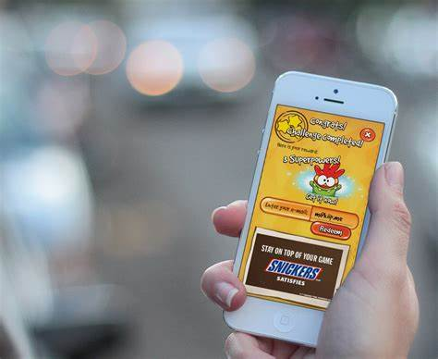
An Integral Ad Science survey of marketing and ad executives finds 76% are prioritizing mobile media for 2022, with more than 80% expecting contextual targeting to grow. Social media is a focus for 72%, and most executives say YouTube, Instagram and Facebook will attract the majority of their media spending, but also noted rising interest in TikTok efforts.
MediaPost Communications (free registration) 12/17/21
https://www.mediapost.com/publications/article/369555/mobile-social-digital-video-are-top-advertising.html
Image credit:
http://insticatorblog.com/wp-content/uploads/2017/03/Untitled1.png

