Mobile AR Advertising Poised For Big Growth
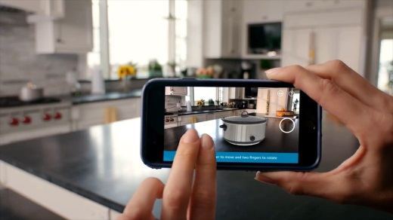
Insider Intelligence predicts marketers will increase their mobile advertising from $194.79 billion this year to $235.67 billion in 2025 to reach the growing number of QR code scanners and augmented reality adopters. Insider Intelligence attributes much of the growth to AR efforts launched via QR codes with out-of-home ads and social media marketers striving to reach the more than 60 million US consumers using AR via social platforms.
Insider Intelligence 1.30.23
https://www.insiderintelligence.com/content/stage-set-mobile-ar-advertising-shine

