Mobile’s Chunk of Ad Dollars Soars
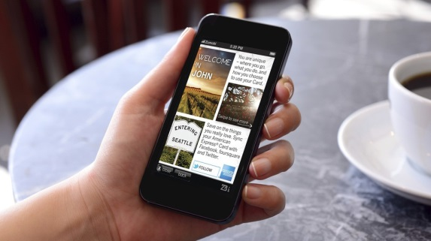
We have reached the mobile tipping point. The average person now spends nearly three hours per day using their mobile devices for non-voice activities, such as surfing the web, texting and playing games. In 2015, for the very first time, mobile will account for the largest share of digital ad spending, according to a new forecast from ad tracking firm eMarketer.
MediaLife 9.2.15
http://www.medialifemagazine.com/mobiles-chunk-of-ad-dollars-soars/

