Why Mobile In-Game Advertising Is Taking Off
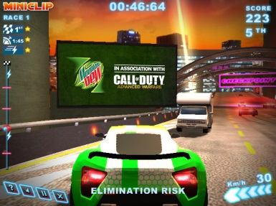
With their ability to augment the gaming experience, rewarded video—video ads that can be launched at key moments in a game in exchange for a small, tangible in-game benefit, such as an extra life or added energy—has found a home in games. Most game developers that offer in-game ads use rewarded video, according to Walnut Unlimited. In fact, only 15% didn’t use them, while 75% did so with other formats.
eMarketer 11.20.19
https://www.emarketer.com/content/why-mobile-in-game-advertising-is-taking-off-and-the-different-ad-formats-available?ecid=NL1001
Image credit:
https://www.rapidfire.com/wp-content/uploads/2015/05/dynamic-in-game-advertising5.jpg

