'Modern Family' Viewers have the Highest Median Household Income
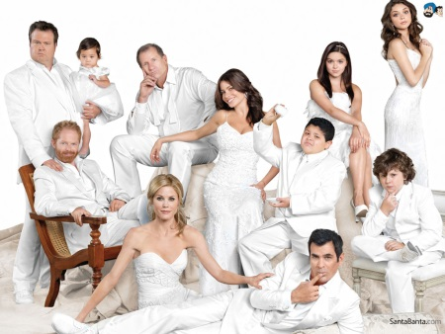
ABC leads the other Big Five with six of the top eight shows in median income among 18-49s. That means that its shows’ 18-49 viewers have higher median incomes than anything else on broadcast TV. Leading the way is the long-running comedy “Modern Family,” with a median income of $90,100.
MediaLife 11.18.16
http://www.medialifemagazine.com/top-shows-among-affluent/

