Modern Luxury Media Purchases GreenGale Publishing
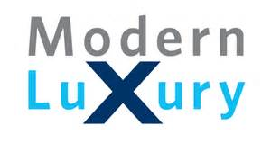
Modern Luxury Media on Monday purchased GreenGale Publishing and its 17 lifestyle brands. Chairman Lew Dickey says the transaction, which brings the portfolio count to 84 regional magazines, "cements our position as a leading luxury media company."
Inside Radio 4/18/17
http://www.insideradio.com/free/dickey-family-expands-its-luxury-magazine-empire/article_536019fc-2406-11e7-9e55-53fd24f1968b.html

