More Artists Petition for DMCA Reform
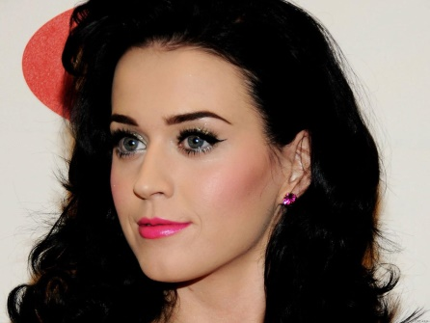
In March, music artists including Steven Tyler, Rod Stewart, Katy Perry and Jon Bon Jovi signed a petition to reform the Digital Millennium Copyright Act. The artists want to reform safe harbor provisions in the DMCA that protect platforms such as YouTube from legal liabilities, arguing that the provisions "[threaten] the continued viability" of music creation.
Music Business Worldwide (UK) 4/25/16
http://www.musicbusinessworldwide.com/artist-backlash-over-youtubes-royalty-payments-grows-noisier/

