More Viewers Are Tuning Into FAST Services
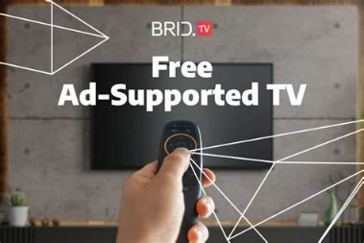
Free ad-supported streaming TV attracted 55% of viewers between January and May, up from 46% late in 2021, Hub Entertainment Research reports. Most FAST viewers say they find the ad loads "reasonable": no more than five commercials an hour and none lasting more than 30 seconds.
Next TV 8.16.22
https://www.nexttv.com/news/fast-usage-was-up-9-points-in-the-first-five-months-of-2022?utm_source=SmartBrief&utm_medium=email&utm_campaign=3E572E13-3FBC-11D5-AD13-000244141872&utm_content=0AB157B5-3910-40B5-A4CF-2CFB83BA3268&utm_term=a25693a1-51b6-4112-bde4-56bd420e983f
Image credit:
https://www.bing.com/images/search?view=detailV2&ccid=jQfqawFg&id=4862AFEB965772EB0B775333E39F1284D7C589B5&thid=OIF.bBVWxwkQS1pJ6QPj26NZ2g&mediaurl=https%3a%2f%2fwww.brid.tv%2fwp-content%2fuploads%2f2022%2f08%2ffree-ad-suported-tv-1194x796.jpg&cdnurl=https%3a%2f%2fth.bing.com%2fth%2fid%2fR.8d07ea6b016040d763bfa82740493b08%3frik%3d%26pid%3dImgRaw%26r%3d0&exph=796&expw=1194&q=ad+supported+streaming+tv&simid=178203830930&FORM=IRPRST&ck=6C1556C709104B5A49E903E3DBA359DA&selectedIndex=0&ajaxhist=0&ajaxserp=0

