MSNBC Reprimands Host Hugh Hewitt
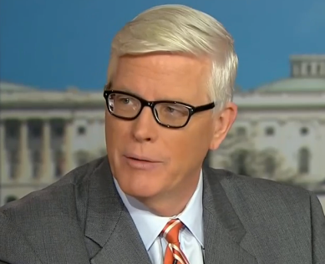
MSNBC has issued a warning to Hugh Hewitt after it was revealed the host personally lobbied embattled Environmental Protection Agency chief Scott Pruitt to cleanup up a toxic waste site near his home in Orange County, Calif.
Philly.com 5.9.18
http://www.philly.com/philly/entertainment/television/msnbc-hugh-hewitt-epa-scott-pruitt-20180509.html
Image credit:
https://asuevents.asu.edu/sites/default/files/12105967_989334491112425_6436888777709014976_n.png

