‘My Entire Life Has Been Spent in a Refugee Center’
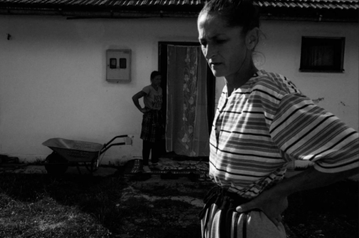
This past December, Hazira returned to her home village, Blječevo, for the first time in 27 years. Situated on a hillside just above Srebrenica in eastern Bosnia and Herzegovina, Blječevo was declared a safe area by a United Nations Security Council resolution in 1993, near the beginning of the Bosnian war.
Pulitzer Center 4.24.20
https://pulitzercenter.org/reporting/my-entire-life-has-been-spent-refugee-center?utm_source=newsletter&utm_medium=email&utm_campaign=4272020
Image credit:
https://pulitzercenter.org/sites/default/files/styles/node_images_768x510/public/04-24-20/franko_pulitzer_srebrenica_04.png?itok=Kd9DiV9N

