NAB, News Media Alliance Appeal Cross-Ownership Ban
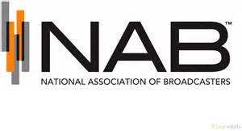
The National Association of Broadcasters and the News Media Alliance have filed separate petitions with the US Court of Appeals for the DC Circuit to reverse the Federal Communications Commission's cross-ownership ban. The NAB called the rules "relics of a long-gone era," while the News Media Alliance said the ban is "antiquated and no longer serves the public interest."
Inside Radio 11/15/16
http://www.insideradio.com/nab-newspaper-group-call-out-fcc-on-cross-ownership/article_1fafc93e-aaff-11e6-bc80-1b03ffe97d5e.html

