NAB, Antennas Direct Give Away 300 TV Antennas in Bay Area
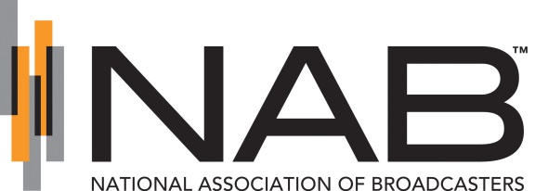
NAB and Antennas Direct joined with the Organization of Chinese Americans to give away 300 TV antennas at the Clayton Hotel in San Francisco on Friday. The antenna-giveaway program is meant to help low-income residents gain access to news, entertainment and "in-language" programming, as well as emergency information, a spokeswoman said.
KRON-TV (San Francisco) 7.4.15
http://kron4.com/2015/07/03/tv-antenna-giveaway-in-san-francisco/

