NAB Presses FCC To Ease Radio Ownership Restrictions
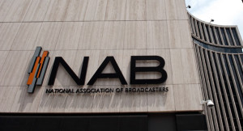
The National Association of Broadcasters is urging the Federal Communications Commission to ease -- but not remove -- limits on how many radio stations a single entity can own in any given market, warning that current restrictions "no longer enable broadcasters to viably operate in a competitive market or effectively serve the public interest."
Radio World 10/19/21
https://www.radioworld.com/news-and-business/business-and-law/more-change-for-radio-ownership-rules?utm_source=SmartBrief&utm_medium=email&utm_campaign=45863C53-9E40-4489-97A3-CC1A29EF491D&utm_content=98CEB9DF-B541-4B83-9571-27BD00CC64E6&utm_term=a25693a1-51b6-4112-bde4-56bd420e983f

