NAB Welcomes Markey's Call To Keep AM In All Cars
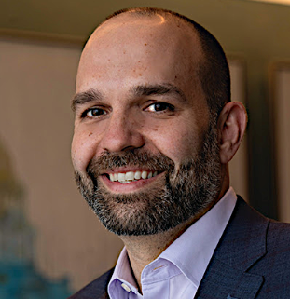
National Association of Broadcasters President and CEO Curtis LeGeyt praised Sen. Edward Markey, D-Mass., for urging carmakers to continue including AM radio in vehicle dashboards, including electric vehicles. "Local radio has a vital place in the auto dashboard and broadcasters remain committed to collaborating with auto manufacturers to address interference and any other concerns that prohibit listeners from easily accessing this essential service," LeGeyt says.
Radio Online 12/1/22
https://news.radio-online.com/articles/b17276/Sen-Markley-Asks-Auto-Manufacturers-to-Keep-AM-Radio
Image credit:

