Nashville Broadcasters Soldier on Following Tornado
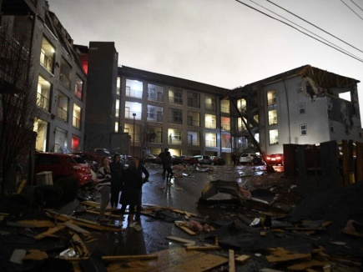
Broadcast stations in Nashville, Tenn., are trying to keep the community informed after yesterday's deadly tornado. Henry Rothenberg and Dan Blommel were live on the air when the tornado touched down and broadcast warnings to nearby residents from WTVF, where they work as a meteorologist and photographer, respectively.
Broadcasting+Cable (free content) 3.3.20
https://www.broadcastingcable.com/blog/nashville-stations-tackle-tornado
Image credit:
https://wordpress-362994-1161349.cloudwaysapps.com/wp-content/uploads/2020/03/57544/tornado-hits-downtown-nashville-at-least-7-die-in-tennessee.jpg

