National Association of Black Journalists Is Investigating CNN’s Hiring
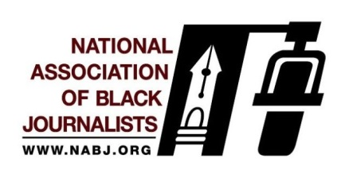
The organization says “a special team will perform further research and an analysis of CNN’s diversity, inclusion and equity practices, per the NABJ Board’s directive,” and that it is calling for “a civil right audit that examines the company’s hiring, promotion and compensation practices involving black employees.”
AdWeek 3.5.19
https://www.adweek.com/tvnewser/national-association-of-black-journalists-is-investigating-cnns-hiring-promotion-and-compensation-practices-involving-black-employees/396066?utm_source=Listrak&utm_medium=Email&utm_term=National+Assoc.+Of+Black+Journalists+Examining+CNN&utm_campaign=NASCAR+Ad+Dollars+Not+Racing+To+Fox%2c+NBC

