Native Advertising Gains Favor in Digital Messaging
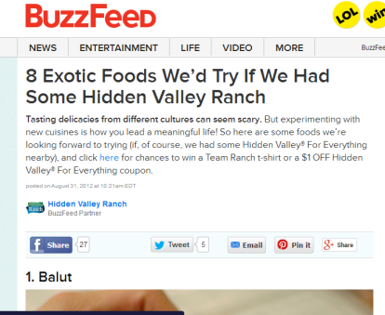
Native advertising is proving to be an effective means of advertising as internet users increasingly disconnect from traditional messaging that is more overt. Native advertising will likely account for 74% of revenues generated from digital display advertising by 2021, BI Intelligence Forecasts predicts.
Marketing Land 11/15/16
http://marketingland.com/native-advertising-new-marketing-workhorse-197856
image source:
http://cdn.blog.cpcstrategy.com/wp-content/uploads/2013/12/native-advertising-buzzfeed-example.png

