NBC Buys Rights to 'Harry Potter,' 'Fantastic Beasts' Franchises
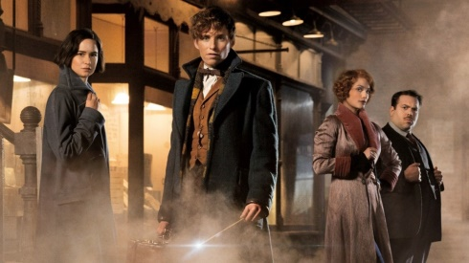
The seven-year deal, which begins in July 2018, will make all eight "Harry Potter" films and the forthcoming "Fantastic Beasts" movies available on NBC's portfolio of cable networks, which include USA and Syfy, according to a company statement Monday. It also lets NBC's theme parks host fan events, movie screenings and promotional activities tied to both franchises. The deal is valued at about $200 million.
Advertising Age 8.8.16
http://adage.com/article/media/nbc-buys-rights-harry-potter-fantastic-beasts-franchises/305367/?utm_source=mediaworks&utm_medium=newsletter&utm_campaign=adage&ttl=1471290375

