NBC's "Female Forward" Aims to Bring More Female Directors to TV
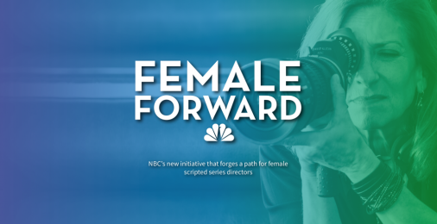
The network has an open call for 10 opportunities to direct in the 2018-19 season. NBC Entertainment President Jennifer Salke is leading the effort with director Lesli Linka Glatter. "The guaranteed commitment to helm an episode, coupled with our incredible council of mentors, will make such a meaningful difference in reaching our goals to create gender parity in the director's chair," Salke said.
Deadline Hollywood 1/9/18
http://deadline.com/2018/01/nbc-female-forward-directors-initiative-jennifer-salke-lesli-linka-glatter-1202239023/
Image credit:
http://i.yomyomf.com/wp-content/uploads/2018/01/09224315/Screen-Shot-2018-01-09-at-10.42.50-PM-1024x527.png

