NBC Hits Record $1.2B in Olympics Ad Sales
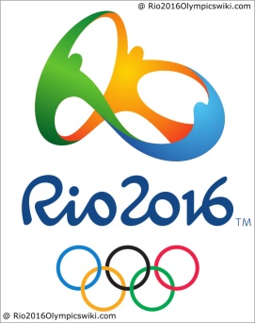
Seth Winter, EVP-advertising sales, NBC Sports Group says NBC has sold $1.2 billion in national advertising time, at a pace about 20% above the 2012 London Games, and is holding back inventory for additional sales. NBC had already sold $1.2 billion in national advertising time, at a pace about 20 percent above the 2012 London Games, and is holding back inventory for additional sales.
Associated Press 8.5.16
http://www.tvnewscheck.com/article/96755/nbc-hits-record-12b-in-olympics-ad-sales?utm_source=Listrak&utm_medium=Email&utm_term=NBC+Hits+Record+%241.2B+In+Olympics+Ad+Sales&utm_campaign=NBC+Hits+Record+%241.2B+In+Olympics+Ad+Sales

