NBC Signs $1B Deal to Retain Premier League Rights
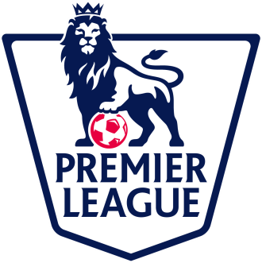
NBC Sports will pay about $1 billion to extend its rights to England's Premier League through the 2021-22 season. NBC was willing to double its annual rate for the three- year pact because the league is important to its sports cable network, NBCSN, and because American demand for high-level European soccer is rising.
The New York Times 8/10/15
http://www.nytimes.com/2015/08/11/sports/soccer/nbc-retains-rights-to-premier-league-in-six-year-deal.html?WT.mc_id=SmartBriefs-Newsletter&WT.mc_ev=click&_r=0

