NBCU Announces Upcoming Ad-Supported Streaming Product
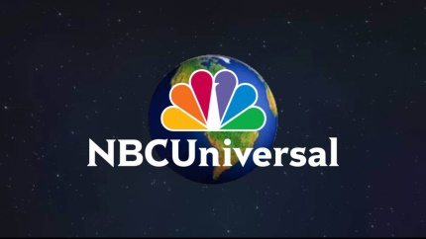
NBCUniversal has announced the 2020 launch of its streaming service, featuring live sports and news, as well as on-demand content. The new ad-supported offering, which will be run by former cable head Bonnie Hammer, will be free to pay-TV customers, while others will be able to buy it for about $12 per month.
Multichannel News 1/14/19
https://www.multichannel.com/news/nbcu-shakes-up-management-looking-ahead-to-streaming

