NBCU, DISH Settle Lawsuit, Carriage Deal
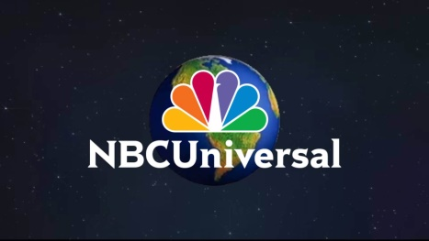
NBCUniversal and DISH Network have come to an agreement that ends the lawsuit over PrimeTime Anytime and AutoHop skip features, and the deal has also settled a retransmission contract dispute. The agreement will allow DISH subscribers to skip ads for a show one week after it has aired.
Deadline.com 6/17/16
http://deadline.com/2016/06/nbc-dish-network-settle-ad-skipping-lawsuit-arbitration-1201774522/

