NBCU Invests $200M in Vox Media
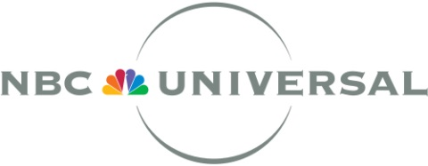
NBCUniversal has taken a $200 million stake in Vox Media, expanding upon a previous investment by sibling Comcast Ventures. The NBCU investment values Vox at about $1 billion, but it has yet to be determined how much of the company it will own. NBCU CEO Steve Burke says the companies will be "building a collaborative partnership involving editorial content, advertising and technology." NBCU also reportedly is investing about $200 million in BuzzFeed, with an announcement likely by Friday.
Re/code 8/12/15
http://recode.net/2015/08/12/nbcuniversal-buys-big-chunks-of-vox-media-and-buzzfeed/

