NBCU Planning Free, Rewards-Based App
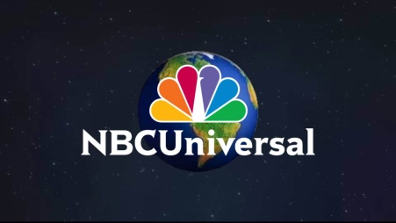
NBCUniversal is developing a free, over-the-top app that will prompt viewers to sample programming in exchange for points that can be redeemed for gift certificates and other perks, a source says. The WatchBack app will reportedly feature content from NBCU properties such as NBC, Bravo and USA, as well as outside programmers.
MediaPost Communications 8/13/18
https://www.mediapost.com/publications/article/323462/nbcuniversal-plans-to-take-a-different-ott-tack-wi.html

