NBCU to Combine Broadcast, Cable Portfolios for Upfront
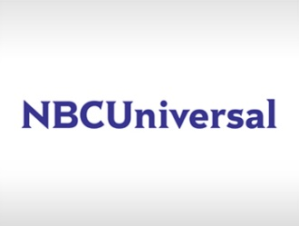
NBCUniversal has announced that it will combine its broadcast and cable networks for its upfront presentation May 15. The company plans to focus on advanced advertising and digital abilities, such as its partnerships with companies including Apple and Snap, at its upfront event at Radio City Music Hall.
Broadcasting & Cable 2/14/17
http://www.broadcastingcable.com/news/currency/nbcu-repeat-combined-upfront-broadcast-and-cable/163312

